Deccan Education Society’s

**NAVINCHANDRA MEHTA INSTITUTE OF TECHNOLOGY AND DEVELOPMENT**

**NAAC Accredited “B++”**

**“Students Project Platform”**

SUBMITTED BY

**C22020 Lalit Narayan Chaudhari**

**Academic Year**

**2022-2023**

**Under the guidance of:**

**Prof. Monisa Rodrigues**

Submitted to University of Mumbai

in partial fulfillment of the requirements for qualifying

MASTER OF COMPUTER APPLICTION

Examination

**Deccan Education Society’s**

NAVINCHANDRA MEHTA INSTITUTE OF TECHNOLOGY AND DEVELOPMENT

**PROJECT CERTIFICATE**

This is to certify that the Project done at _**Deccan Education Society NMITD** by Mr. **Lalit Narayan Chaudhari**(Seat No. C22020) in partial fulfillment for MCA Degree Examination has been found satisfactory. This report had not been submitted for any other examination and does not form part of any other course undergone by the candidate.

Internal Guide Director

EXAMINED BY

EXTERNAL EXAMINER ………………………………

DATE:

College Stamp

**List of Figures:**

|  |  |  |  |
| --- | --- | --- | --- |
| **Sr. No.** | **Figure Number** | **Title** | **Page Number** |
| 1 | 2.1 | Work Breakdown Structure | 11 |
| 2 | 2.2 | Activity Network Diagram | 11 |
| 3 | 2.3 | Gantt Chart | 12 |
| 4 | 3.1 | Use Case Diagram | 13 |
| 5 | 3.2 | ER Diagram | 14 |

**INDEX**

|  |  |  |  |
| --- | --- | --- | --- |
| **Chapter** |  | **Contents** | **Page No.** |
| **I** |  | **Introduction** |  |
|  | 1.1 | Survey/ Exploratory Study for Requirements Identification | 7 |
|  | 1.2 | Problem statement | 9 |
|  | 1.3 | Background of Problem/ Idea | 10 |
|  |  |  |  |
| **II** |  | **Project Planning and Scheduling** |  |
|  | 2.1 | Work Breakdown Structure | 11 |
|  | 2.2 | Activity Network Diagram | 11 |
|  | 2.3 | Gantt Chart | 12 |
|  |  |  |  |
| **III** |  | **Analysis and Design** |  |
|  | 3.1 | Use Case Diagram | 13 |
|  | 3.2 | ER Diagram | 14 |
|  |  |  |  |
| **IV** |  | **Implementation** | 15 |
|  |  |  |  |
| **V** |  | **Testing** | 26 |
|  |  |  |  |
| **VI** |  | **Future Enhancements** | 27 |
|  |  |  |  |
| **VII** |  | **Conclusion** | 28 |
|  |  |  |  |
| **VIII** |  | **References** | 29 |

# **Acknowledgement**

Achievement is finding out what you would be doing rather than what you have to do. It is not until you undertake such a project that you realize how much effort and hard work it really is, what are your capabilities and how well you can present yourself or other things. It gives me immense pleasure to present this report towards the fulfilment of my project.

It has been rightly said that we are built on the shoulder of others. For everything I have achieved, the credit goes to all those who had helped me to complete this project successfully.

I take this opportunity to express my profound gratitude to management of DES NMITD for giving me this opportunity to accomplish this project work.

I am very much thankful to **Dr. Anita Bobade madam** – Director of DES NMITD College for their kind co-operation in the completion of my project.

A special vote of thanks to our HOD **Dr. Rasika Mallya ma’am** and to our project guide **Mrs. Monisa Rodrigues ma’am**. Thanks to all our teachers **Mrs. Swapnali Mahadik ma’am** and **Mr. Pratik Desai sir** for helping and guiding me throughout my project.

Finally, I would like to thank all my classmate & entire MCA department who directly or indirectly helped me in completion of this project & to my family without whose support, motivation & encouragement this would not have been possible.

**Abstract**

The project focuses on developing an online integrated platform to streamline the documentation process and enhance accessibility for student projects across various universities and colleges in India. This platform serves as a centralized repository, facilitating efficient knowledge sharing, promoting innovation, and encouraging cross-institutional collaboration. Through a comprehensive survey and exploratory study, key requirements for the platform have been identified, including robust categorization, advanced search functionalities, plagiarism detection mechanisms, user-friendly interfaces, and stringent data privacy measures.

The platform addresses the existing challenges in accessing project resources, collaborating with peers, and ensuring academic integrity by providing a secure and authentic environment for students to showcase their work. By leveraging technology, this initiative aims to transform the traditional approach to project documentation, fostering a culture of continuous learning and academic excellence among students.

Overall, the online integrated platform represents a significant step towards improving the educational landscape in Indian universities and colleges, empowering students to explore unique and innovative project opportunities while contributing to the broader academic community through cross-functional research and collaboration.

# **Chapter I**

# **Introduction**

* 1. **Survey/ Exploratory Study for Requirements Identification**

Identifying and focus on gathering insights from stakeholders involved in student project documentation across Indian universities and colleges. This study aims to understand the current practices, challenges, and desired features related to project documentation. Key areas of exploration include:

1. Current Practices: Investigating how student projects are currently documented and shared within institutions, including the methods used for storage, access, and dissemination.

2. Challenges Faced: Identifying the primary challenges encountered by students, educators, and administrators in the process of documenting and accessing project materials. This includes issues such as limited visibility, lack of standardized formats, and difficulties in collaboration.

3. Desired Features: Soliciting feedback on the essential features and functionalities that stakeholders would like to see in an online integrated platform for project documentation. This includes preferences for categorization, search options, collaboration tools, plagiarism detection mechanisms, and user interface design.

4. Data Privacy Concerns: Assessing concerns related to data privacy and security when sharing project materials on an online platform, and identifying measures to address these concerns effectively.

Through this survey and exploratory study, valuable insights will be gathered to inform the design and development of the online integrated platform, ensuring that it meets the needs and preferences of the diverse stakeholders involved in student project documentation across Indian educational institutions.

Top of Form

**Software Requirements:**

* Operating System: Windows
* Front-end: HTML, CSS, JavaScript, Bootstrap
* Back-end: MySQL, Node.js, Express.js
* Tools: Visual Studio Code

**Hardware Requirements:**

* RAM: 4GB or Above
* Hard Disk: 250GB
* Processor: Dual Core

**1.2 Problem Statement**

**ID:** SIH1369

**Title:** Online integrated platform for projects taken up by the students of various universities/colleges

**Technology Bucket:** Smart Education

**Category:** Software

**Description:** Innovation is the key to betterment of education and students in the Indian universities/colleges put a lot of efforts on the projects as a part of the academic requirements. If a common knowledge platform (with a facility for plagiarism) is created to bring all project works taken up at various levels by the students in Technical / Higher Educational Institutes and Universities throughout the country, then it will be a great source of knowledge and also will help the student community to take up unique/innovative project works Summary: An integrated platform should be developed where in all the universities/Colleges provide information about the projects done by the students. The information on this platform will help in the peer learning and this will also help in cross functional research between various universities/colleges. Objective: To develop an online integrated platform for projects taken up by the students of various universities/colleges.

**Problem Creator’s Organization:** Government of Jharkhand

**Problem Creator’s Department:** Department of Higher and Technical Education

**1.3 Background**

The background of the problem revolves around the fact that students in Indian universities and colleges often undertake projects as part of their academic curriculum. These projects are crucial for their learning and skill development. However, there is currently no centralized platform where students can showcase their projects, share knowledge, and engage in cross-functional research.

The idea is to address this issue by creating an online integrated platform specifically designed for students to upload information about their projects. This platform would serve as a repository of project works undertaken by students across various technical and higher educational institutes and universities throughout the country.

The main objectives of this platform are:

1. Knowledge Sharing: To provide a common platform where students can share information about their projects, including methodologies, results, and conclusions.

2. Plagiarism Detection: To incorporate tools and mechanisms to detect plagiarism, ensuring that the projects uploaded are original and not copied from other sources.

3. Peer Learning: To facilitate peer learning by allowing students to access and learn from projects undertaken by their peers in different universities and colleges.

4. Cross-Functional Research: To promote collaboration and cross-functional research among students from different educational institutions by providing a platform for sharing ideas and insights.

5. **Promoting Innovation: ** To encourage students to undertake unique and innovative project works by showcasing successful projects and inspiring others to explore new ideas.

Overall, the development of this online integrated platform aims to enhance the educational experience of students, promote knowledge sharing, and foster a culture of innovation and collaboration within the academic community. Top of Form

# **Chapter II:**

# **Project Planning and Scheduling**

# **2.1 Work Breakdown Structure**

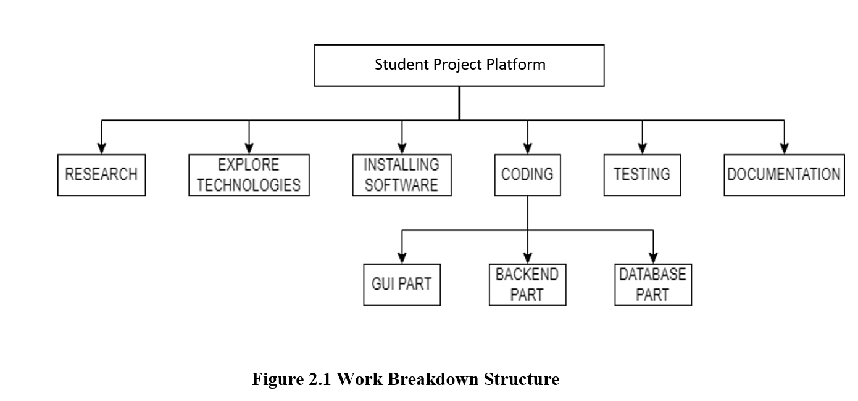

**2.2 Activity Network Diagram**

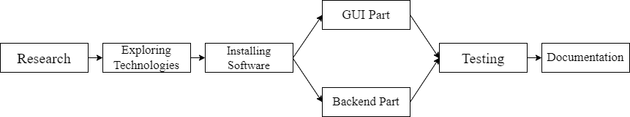

**Figure 2.2 Activity Network Diagram**

**2.3 Gantt Chart**

**Figure 2.3 Gantt Chart**

# **Chapter III:**

# **Analysis and Design**

**3.1 Use Case Diagram**

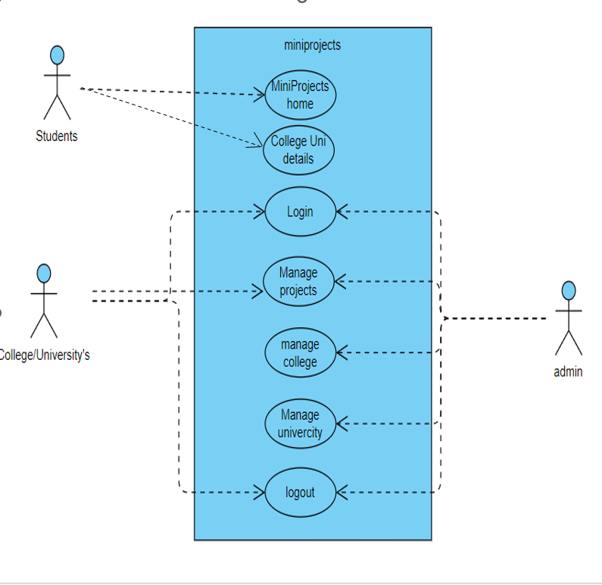

**Figure 3.1 Use Case Diagram**

**3.2 ER diagram**

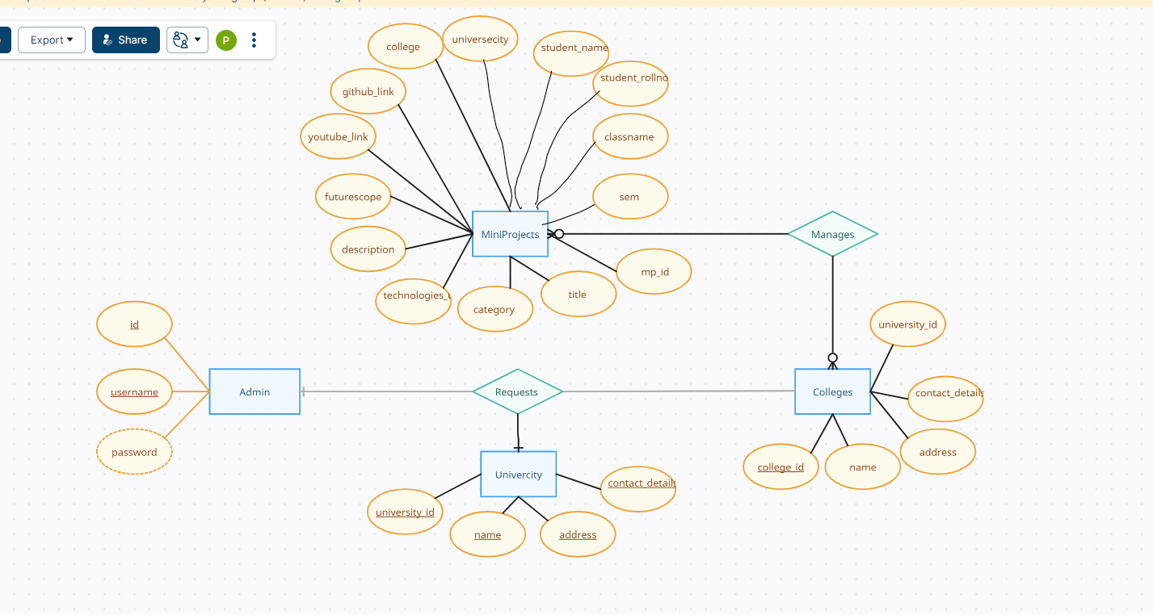

**Figure 3.2 ER Diagram**

# **Chapter IV:**

# **Implementation**

The project needs some basic requirements which you must fulfil as given below.

**Source code**

**Index.html**

<!DOCTYPE html>

<html lang="end">

<head>

  <meta charset="UTF-8">

  <meta name="viewport" content="width=device-width, initial-scale=1.0">

  <title>Students Project Platform</title>

  <link rel="stylesheet" href="https://maxcdn.bootstrapcdn.com/bootstrap/4.0.0/css/bootstrap.min.css">

</head>

<body>

  <nav class="navbar navbar-expand-lg navbar-light bg-light">

      <a class="navbar-brand" href="#">Students Project Platform</a>

      <button class="navbar-toggler" type="button" data-toggle="collapse" data-target="#navbarNav" aria-controls="navbarNav" aria-expanded="false" aria-label="Toggle navigation">

        <span class="navbar-toggler-icon"></span>

      </button>

      <div class="collapse navbar-collapse" id="navbarNav">

          <ul class="navbar-nav">

            <li class="nav-item active">

              <a class="nav-link" href="/index.html">Home <span class="sr-only">(current)</span></a>

            </li>

            <li class="nav-item active">

              <a class="nav-link" href="/category.html">Categories <span class="sr-only">(current)</span></a>

            </li>

            <li class="nav-item active">

              <a class="nav-link" href="/college.html">Colleges <span class="sr-only">(current)</span></a>

            </li>

            <li class="nav-item active">

              <a class="nav-link" href="/university.html">University <span class="sr-only">(current)</span></a>

            </li>

            <li class="nav-item active">

              <a class="nav-link" href="/aboutus.html">About Us <span class="sr-only">(current)</span></a>

            </li>

            <li class="nav-item active">

              <a class="nav-link" href="/contactus.html">Contact Us <span class="sr-only">(current)</span></a>

            </li>

          </ul>

      <!-- Add this textbox in your navbar -->

      <form id="search-form" class="form-inline my-2 my-lg-0">

        <input id="search-input" class="form-control mr-sm-2" type="search" placeholder="Search" aria-label="Search">

        <button class="btn btn-outline-success my-2 my-sm-0" type="submit">Search</button>

      </form>

    </div>

  </nav>

  <div class="container mt-4" id="projects-list"></div>

  <!-- Add this button at the bottom of your webpage -->

  <div class="container mt-4">

    <button id="scrollToTopBtn" class="btn btn-primary" style="display: none;">Back to Top</button>

      <center>

        <button id="prev-btn" class="btn btn-secondary">Previous</button>

        <span id="page-number" class="ml-2"></span>

        <button id="next-btn" class="btn btn-secondary ml-2">Next</button>

      </center>

  </div>

  <div class="container text-center">

    <p>&copy; 2023 Mini Projects</p>

  </div>

  <script src="app.js"></script>

</body>

</html>

**App.js**

// index manu

// Define the number of records to display per page

const recordsPerPage = 10;

// Variable to track the current page

let currentPage = 1;

document.addEventListener('DOMContentLoaded', function () {

fetchAndRenderProjects();

// Event listener for next and previous buttons

document.getElementById('next-btn').addEventListener('click', () => {

currentPage++;

fetchAndRenderProjects();

});

document.getElementById('prev-btn').addEventListener('click', () => {

if (currentPage > 1) {

currentPage--;

fetchAndRenderProjects();

}

});

});

function fetchAndRenderProjects() {

fetch(`/api/projects?page=${currentPage}&perPage=${recordsPerPage}`)

.then(response => response.json())

.then(projects => renderProjects(projects))

.catch(error => console.error('Error fetching projects:', error));

}

function renderProjects(projects) {

const projectsList = document.getElementById('projects-list');

projectsList.innerHTML = ''; // Clear existing projects

projects.forEach(project => {

const projectCard = document.createElement('div');

projectCard.classList.add('card', 'project-card');

projectCard.innerHTML = `

<h2 class="card-title">${project.title}</h2>

<p class="card-text">${project.mp_id}</p>

<p class="card-text">${project.short_description}</p>

<p class="card-text">Category: ${project.category}</p>

<p class="card-text">Technologies Used: ${project.technologies_used}</p>

<p class="card-text">Year: ${project.year}</p>

<p class="card-text"><button class="btn btn-primary" onclick="viewProject(${project.mp_id})">View</button></p>

`;

projectsList.appendChild(projectCard);

});

// Update pagination numbering in the footer

updatePaginationNumbering();

}

function updatePaginationNumbering() {

const pageNumberContainer = document.getElementById('page-number');

pageNumberContainer.textContent = `Page ${currentPage}`;

}

function viewProject(projectId) {

window.location.href = `projectDetails.html?id=${projectId}`;

}

function fetchAndRenderProjects() {

fetch(`/api/projects?page=${currentPage}&perPage=${recordsPerPage}`)

.then(response => response.json())

.then(projects => renderProjects(projects))

.catch(error => console.error('Error fetching projects:', error));

}

//searc

document.addEventListener('DOMContentLoaded', function () {

const searchForm = document.getElementById('search-form');

searchForm.addEventListener('submit', handleSearch);

});

function handleSearch(event) {

event.preventDefault();

const searchInput = document.getElementById('search-input').value.trim();

fetch(`/api/search?query=${encodeURIComponent(searchInput)}`)

.then(response => {

if (!response.ok) {

throw new Error('Network response was not ok');

}

return response.json();

})

.then(projects => {

if (!Array.isArray(projects)) {

throw new Error('Projects data is not an array');

}

renderProjects(projects);

})

.catch(error => console.error('Error searching projects:', error));

}

// ... (remaining code)

// JavaScript: Dynamically show/hide button based on scroll position

document.addEventListener('DOMContentLoaded', function () {

const scrollToTopBtn = document.getElementById('scrollToTopBtn');

// Show button when user scrolls to the bottom

window.addEventListener('scroll', function () {

if (document.body.scrollTop > 20 || document.documentElement.scrollTop > 20) {

scrollToTopBtn.style.display = 'block';

} else {

scrollToTopBtn.style.display = 'none';

}

});

// Scroll to top when button is clicked

scrollToTopBtn.addEventListener('click', function () {

document.body.scrollTop = 0; // For Safari

document.documentElement.scrollTop = 0; // For Chrome, Firefox, IE and Opera

});

});

# **Server.js**

const express = require('express');

const bodyParser = require('body-parser');

const mysql = require('mysql');

const path = require('path');

Const app = express();

app.use(express.static('public'));

const port = 3000;

// Create a MySQL connection

const connection = mysql.createConnection({

host: 'localhost',

user: 'root',

password: 'root',

database: 'project',

});

// Connect to MySQL

connection.connect();

// Middleware to parse JSON

app.use(bodyParser.json());

app.use(express.static(path.join(__dirname, 'public')));

// API endpoint to get all projects

app.get('/api/projects', (req, res) => {

const page = parseInt(req.query.page) || 1;

const perPage = parseInt(req.query.perPage) || 10;

const offset = (page - 1) * perPage;

const query = 'SELECT * FROM miniproject ORDER BY mp_id DESC LIMIT ?, ?';

connection.query(query, [offset, perPage], (error, results) => {

if (error) {

console.error('Error fetching projects:', error);

res.status(500).json({ error: 'Internal Server Error' });

} else {

res.json(results);

}

});

});

//api to get induviau project

app.get('/api/projects/:id', (req, res) => {

const projectId = req.params.id;

const query = 'SELECT * FROM miniproject WHERE mp_id = ?';

connection.query(query, [projectId], (error, results) => {

if (error) {

console.error('Error fetching project details:', error);

res.status(500).json({ error: 'Internal Server Error' });

} else {

if (results.length === 0) {

res.status(404).json({ error: 'Project not found' });

} else {

const projectDetails = results[0];

res.json(projectDetails);

}

}

});

});

// Define API endpoint for searching projects

app.get('/api/search', (req, res) => {

const searchQuery = req.query.query;

if (!searchQuery) {

return res.status(400).json({ error: 'Missing search query' });

}

const query = ` SELECT * FROM miniproject

WHERE

title LIKE ? OR

category LIKE ? OR

technologies_used LIKE ? OR

description LIKE ? OR

futurescope LIKE ? OR

student_names LIKE ? OR

college LIKE ? OR

universecity LIKE ?

`;

const queryParams = Array(8).fill(`%${searchQuery}%`);

connection.query(query, queryParams, (error, results) => {

if (error) {

console.error('Error searching projects:', error);

res.status(500).json({ error: 'Internal Server Error' });

} else {

res.json(results);

}

});

});

// Fetch all colleges

app.get('/colleges', (req, res) => {

connection.query('SELECT * FROM college', (err, results) => {

if (err) {

console.error('Error fetching colleges:', err);

res.status(500).send('Internal Server Error');

} else {

res.json(results);

}

});

});

// Fetch all universities

app.get('/universities', (req, res) => {

connection.query('SELECT * FROM university', (err, results) => {

if (err) {

console.error('Error fetching universities:', err);

res.status(500).send('Internal Server Error');

} else {

res.json(results);

}

});

});

app.get('/categories', (req, res) => {

const query = 'SELECT DISTINCT category FROM miniproject;';

connection.query(query, (err, results) => {

if (err) {

console.error('Error fetching categories:', err);

res.status(500).json({ error: 'Internal Server Error' });

return;

}

const categories = results.map(result => result.category);

res.json(categories);

});

});

// Get records by category

app.get('/records', (req, res) => {

const category = req.query.category;

const query = 'SELECT * FROM miniproject WHERE category = ?;';

connection.query(query, [category], (err, results) => {

if (err) {

console.error(`Error fetching records for category ${category}:`, err);

res.status(500).json({ error: 'Internal Server Error' });

return;

}

res.json(results);

});

});

// Route to fetch university details

app.get('/university-details', (req, res) => {

const universityId = req.query.id; // Assuming you pass university id in query parameter

const query = 'SELECT * FROM university WHERE university_id = ?';

connection.query(query, [universityId], (err, results) => {

if (err) {

console.error('Error fetching university details:', err);

res.status(500).send('Internal Server Error');

} else {

if (results.length > 0) {

const universityDetails = results[0];

res.json(universityDetails);

} else {

res.status(404).send('University not found');

}

}

});

});

// Route to fetch college details

app.get('/college-details', (req, res) => {

const collegeId = req.query.id; // Assuming you pass college id in query parameter

const query = 'SELECT * FROM college WHERE college_id = ?';

connection.query(query, [collegeId], (err, results) => {

if (err) {

console.error('Error fetching college details:', err);

res.status(500).send('Internal Server Error');

} else {

if (results.length > 0) {

const collegeDetails = results[0];

res.json(collegeDetails);

} else {

res.status(404).send('College not found');

}

}

});

});

app.post('/submit_registration', (req, res) => {

const { collegeName, address, contactDetails, universityId } = req.body;

const sql = 'INSERT INTO request (college_name, address, contact_details, university_id) VALUES (?, ?, ?, ?)';

const values = [collegeName, address, contactDetails, universityId];

connection.query(sql, values, (err, result) => {

if (err) {

console.error(err);

res.status(500).send('Error occurred while processing your request.');

} else {

console.log('Registration successful!');

res.send('Registration successful!');

}

});

});

app.listen(port, () => {

console.log(`Server is running on http://localhost:${port}`);

})

# **Chapter V:**

# **Testing**

|  |  |  |  |  |
| --- | --- | --- | --- | --- |
| **Case** | **Input** | **Expected output** | **Actual output** | **Result** |
| On click on view project |  | projectDetails should be displayed | projectDetails should be displayed | pass |
| On click on view project |  | projectDetails should be displayed | Error | Fail |
| Search form | Search text | Relevant projects displaced | Relevant projects displaced | pass |
| Search form | Search text | Relevant projects displaced | Relevant projects Not displaced | Fail |
| Login form | admin,admin | Dashboard should display | Dashboard displayed | pass |
| Login form | admin,hbhvbhj | Dashboard should display | Dashboard not display | pass |
| Login form | admin,admin | Dashboard should display | Dashboard not display | Fail |
| Login form | admin,hbhvbhj | Dashboard should display | Dashboard display | Fail |
| Request | College name, address, contactdetails | On admin panel request Display | On admin panel request visible | pass |
| Request | College name, address, contactdetails | On admin panel request Display | On admin panel request not Display | Fail |

# **Chapter VI:**

# **Future Enhancement**

* Automatic HTML Formatter
* Instead of mysql mongoDB Can be used for better performance
* Ai model can be added to avoid repetitiveness
* Iterative Categories can be added
* Filter functions can be added
* Microsite can be added for famous college.

.

# **Chapter VII:**

# **Conclusion**

# The Student Projects Platform is a comprehensive solution that addresses the needs of students, educators, and researchers in the higher education sector. By providing a centralized repository for project works, the platform facilitates knowledge sharing, collaboration, and innovation among students from various universities and colleges across the country.

# One of the key strengths of the platform is its emphasis on peer learning. By allowing students to explore and learn from the projects undertaken by their peers, the platform fosters a culture of continuous learning and skill development. This peer learning aspect not only enhances the academic experience of students but also encourages them to explore diverse topics and disciplines beyond their own areas of study.

# Furthermore, the platform promotes cross-functional research and collaboration. By providing access to a diverse range of project works from different institutions and disciplines, students are encouraged to collaborate on interdisciplinary projects and engage in cross-functional research endeavors. This interdisciplinary approach not only enriches the learning experience but also prepares students for real-world challenges where interdisciplinary collaboration is often essential.

# The inclusion of a plagiarism detection feature underscores the platform’s commitment to academic integrity and originality. By implementing robust plagiarism detection mechanisms, the platform ensures that all project submissions are authentic and original, thus upholding the standards of academic excellence and integrity.

# In addition to benefiting students, the platform also serves as a valuable resource for educators and researchers. Educators can leverage the platform to access a wide range of project works for teaching purposes, while researchers can use it to discover new ideas, trends, and research directions across various disciplines.

# Overall, the Student Projects Platform plays a significant role in enhancing the quality of education and research in universities and colleges throughout the country. By fostering a culture of innovation, collaboration, and academic integrity, the platform contributes to the holistic development of students and promotes excellence in higher education.

Feel free to customize and tailor this expanded conclusion based on the specific achievements, outcomes, and impacts of your project. Top of Form

# **Chapter VIII:**

# **References:**

* https://chat.openai.com/share/502c3f89-6f48-4027-a041-17615eddee94
* https://chat.openai.com/share/ddbe2b64-b8cb-4d3b-936f-c99f41c30617
* https://chat.openai.com/share/ddbe2b64-b8cb-4d3b-936f-c99f41c30617
* https://chat.openai.com/share/93b595c9-5b37-4871-8f9f-7f5245ea0897
* https://chat.openai.com/share/67ca30de-2602-4c18-94d1-c615b70f16b6
* https://chat.openai.com/share/67ca30de-2602-4c18-94d1-c615b70f16b6
* https://chat.openai.com/share/bf6f20ce-01e2-41d3-9178-750a3feb977a